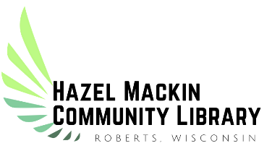

2022 Hazel Mackin Community Library
ADULT
Summer Program Registration
“Oceans of Possibilities”

Name: _______________________________________________________________________________
Address: _____________________________________________________________________________
Phone: ______________________________________________________________________________
Email Address: ________________________________________________________________________
Hazel Mackin Community Library
311 W. Warren Street
Roberts, WI 54023
www.robertspubliclibrary.org
715-749-3849

Permission to Videotape and/or Photograph

I ____________________________________ am 18 years or older.
_{(Name, please print)}

I understand the Village of Roberts may photograph or videotape the events or activity in which I am participating. I give permission for the Village to use photographs or videotape of me for the purpose of promoting the Village of Roberts and its services/ programs. I give my permission with the following understanding: No compensation of any kind will be paid to me at this time or in the future for the use of my likeness.
Permission is not required to take part in city events.

Signature: ______________________________________________________ Date: ________________

