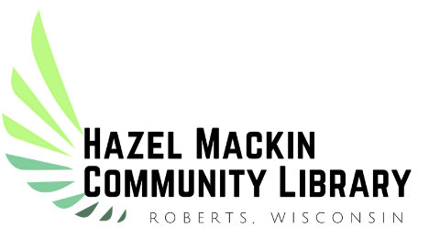
2022 Summer Library Program
“Oceans of Possibilities”
KIDS’ Registration Ages Toddler-17
Name: _______________________________________________________________________________
Address: _____________________________________________________________________________
Phone: _______________________________________________________________________________
Email Address: ________________________________________________________________________
Age: _______________
Hazel Mackin Community Library
311 W. Warren St.
Roberts, WI 54023

Permission to Videotape and/or Photograph

I ____________________________________ am the parent or legal guardian of ___________________.
_{(Parent name, please print)} _{(Child name, age)}

I understand the Village of Roberts may photograph or videotape the events or activity in which I am (or my child is) participating. I give permission for the Village to use photographs or videotape of me (or my child) for the purpose of promoting the Village of Roberts and its services/ programs. I give my permission with the following understanding: No compensation of any kind will be paid to me (or my child) at this time or in the future for the use of my (or my child’s) likeness.
Permission is not required to take part in city events.

Signature: ______________________________________________________ Date: ________________

